In this report, I am proposing how we can use time-space cube in visualizing a spatial-temporal dataset. Honestly, I believe that weather datasets, given their temporal and spatial essence, are a great match for this type of visualization. This is also what I am planning to do for my own project as well. For this reading, though, I considered the weather dataset in Kaggle, which can be found [here](https://www.kaggle.com/PROPPG-PPG/hourly-weather-surface-brazil-southeast-region?select=sudeste.csv). This dataset contains the information recorded in 122 weather stations in southern Brazil. Different features such as temperature, humidity, wind and precipitation are recorded and available in this dataset.

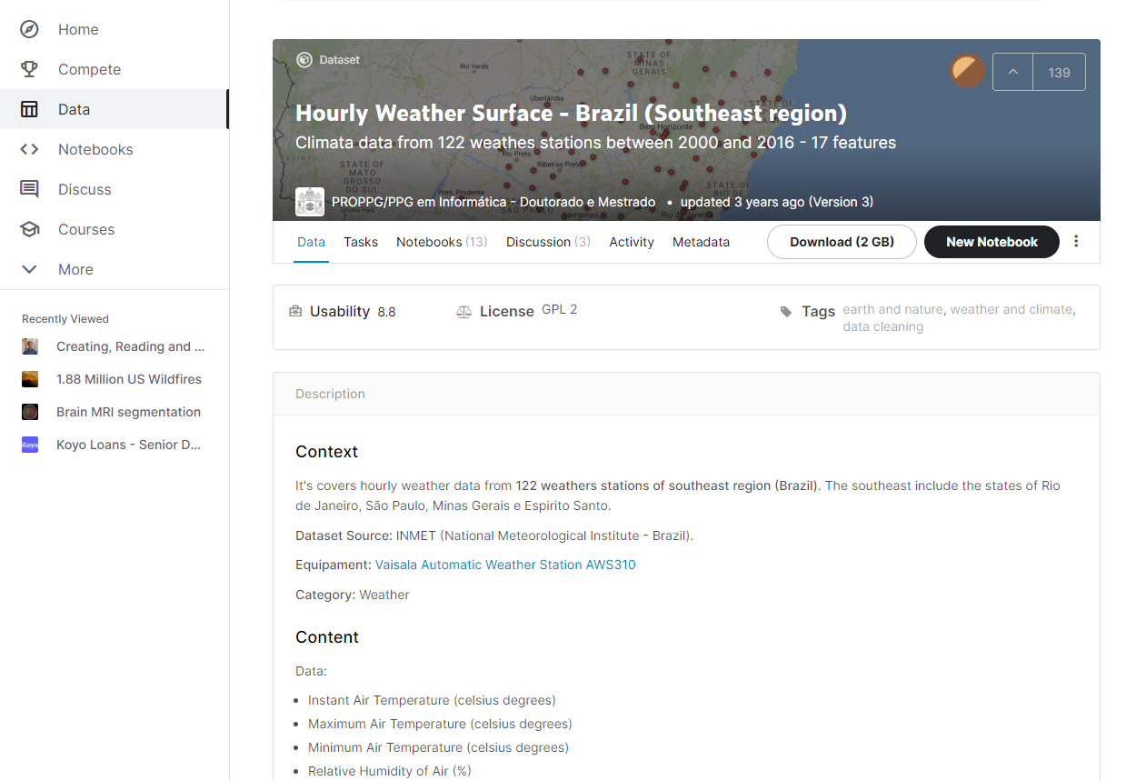

What I think would be a great fit for this dataset is geo time, either 3D rendering version or the space flattening. What we can do is to consider the geo map of the stations on the bottom and use time axis to visualize any single attribute, say temperature, and visualize the variation in the considered feature in time. One of the most beneficial points of this visualization would be anomaly detection. Usually weather stations have some errors every now and then in their records due to error in devices. Therefore, with this visualization, we can detect any possible anomaly, visually, and clean our dataset, which would be a huge advantage in big datasets, like the one I used here. The other advantage could be finding any specific trends in the dataset. For example, by comparing maximum temperature recorded in two different weather stations, we can compare different trends observed and investigate any possible reason behind that.